Uncertainty and Social information use in Adolescence

***Abstract***

**Keywords:** Social Influence; Hierarchical Bayes; Uncertainty

also apply to preferences, rule and outcome uncertainty.

***Introduction***

Adolescence is often associated with an increase in risky behaviors. Adolescents use drugs, binge drink, are often reckless or rebellious and have unprotected intercourse (Barch et al., 2017). However, a meta-analysis of recent experimental research suggests that risk-taking steadily declines from child to adulthood (Defoe, Dubas, Figner, & van Aken, 2015; Defoe, Semon Dubas, & Romer, 2019). How does this *decrease* in the labmatch the increase in adolescent risk-taking in real life? Recently, it has been suggested that this discrepancy could be attributed to the mismatch between experimental paradigms and the ecology of adolescent risk taking. It is argued that the typical experimental paradigms do not match the uncertainty that adolescents face in real life (Rosenbaum & Hartley, 2019; Rosenbaum, Venkatraman, Steinberg, & Chein, 2018; Tymula et al., 2012; van den Bos & Hertwig, 2017).

As a consequence of their uncertainties, adolescents likely only a vague idea about the quality and probability of all possible consequences of their actions. There is no one-size-fits-all solution that would accurately list all information about the individual consequences of reckless and risky behaviors, like speeding or using drugs. However when studying the development of risk-taking experimentally, such information is often provided by explicitly stating the exact probabilities of gains or losses for every decision (Chung, Christopoulos, King-Casas, Ball, & Chiu, 2015; Ciranka & van den Bos, 2019; Haddad, Harrison, Norman, & Lau, 2014; Reiter, Suzuki, O’Doherty, Li, & Eppinger, 2019; Smith, Chein, & Steinberg, 2014). Experimental tasks, like the Balloon Analogue Risk Task (BART), that involve decisions under uncertainty seem to better capture real world trends in risk behavior (Defoe, Dubas, Figner, & Aken, 2014; Lejuez et al., 2003; Rosenbaum & Hartley, 2019). Developmental research using such paradigms suggests that when adolescents make decisions under uncertainty, they are more optimistic about the consequences of their choice (Tymula et al., 2012), and search for less information before making consequential decisions (van den Bos & Hertwig, 2017). Arguably, their positive attitude towards uncertainty might lead adolescents to a have a higher propensity to take risks. However, this propensity is likely not domain general but tightly connected to social contexts (Blakemore & Mills, 2014; Blakemore & Robbins, 2012). Evidence suggests that social factors are among the most prominent to motivate adolescents to take a leap into the unknown (Albert & Steinberg, 2011; Blakemore & Robbins, 2012; Crone & Dahl, 2012; Telzer, van Hoorn, Rogers, & Do, 2018). However, the adolescent social context is complex and the mechanisms behind social influence are not well understood. Where some researchers have focused on developmental differences in the arousal associated with being observed (Smith et al., 2014), or developmental differences in the social motivation to belong to a peer group (Crone & Dahl, 2012), here we focus on how individuals use social information to reduce uncertainty. Research on social information use, such getting advice or observing others’ behavior, squares remarkably well with that of decisions under uncertainty. It is for example well established that when adults are more uncertain, they are more likely to rely on social information (Bahrami et al., 2010; Ciranka & van den Bos, 2020; FeldmanHall & Shenhav, 2019; Toelch & Dolan, 2015). Even studies with infants have long shown that when they are uncertain of how to behave, they seek more eye contact with their caregivers (Walden & Ogan, 1988; Zarbatany & Lamb, 1985). However, how adolescents leverage social information when faced with uncertainty is currently not understood.

The goal of this study is therefore to investigate (1) how adolescents take risks under uncertainty, and (2) how adolescents make use of social information under uncertainty. To this end, we have developed a novel experimental task and formulated a Bayesian model of social influence in risk taking. The most frequently used tasks to study risk taking under uncertainty in adolescents (Gardner & Steinberg, 2005; Lejuez et al., 2003), require subjects to learn possible outcomes and their probabilities by observing the feedback in a trial and error fashion. However, this introduces confounds, which make it hard to disentangle learning processes from risk attitudes (Schonberg, Fox, & Poldrack, 2011). This is specifically problematic in developmental studies for two reasons. First, information sampling strategies may differ through development, resulting in different experiences on which individuals base their decisions (Gopnik, Griffiths, & Lucas, 2015; Schulz, Wu, Ruggeri, & Meder, 2019; van den Bos & Hertwig, 2017). Second, given that learning from feedback (for instance reinforcement learning) shows significant developmental changes until late adolescence (Davidow, Foerde, Galván, & Shohamy, 2016; Nussenbaum & Hartley, 2019; Palminteri, Kilford, Coricelli, & Blakemore, 2016a; van den Bos, Cohen, Kahnt, & Crone, 2012), adolescents will likely hold different beliefs than adults even after making the same sampling experience. In the current work we therefore have separated the learning phase from the decision phase and we fixed the amount of evidence shown to the subjects before they committed to a choice. As a result, we are able to disentangle experience-based learning from decision-making processes and make sure that subjects of all ages base their decision on the same amount of experience. However even without feedback, the same experience may still result in different beliefs about outcomes between individuals. To understand these differences, we rely on formal modeling. One advantage of formal models is that they provide access to latent variables that otherwise cannot be directly observed from behavior (Ciranka & van den Bos, 2019; Hauser, Will, Dubois, & Dolan, 2018; Pfeifer, Allen, Byrne, & Mills, 2018; van den Bos, Bruckner, Nassar, Mata, & Eppinger, 2017). Bayesian models for instance make individual uncertainties explicit, and have been particularly insightful to comprehend differences in trial and error learning under uncertainty in aging and psychiatric populations (Browning, Behrens, Jocham, O’Reilly, & Bishop, 2015; Nassar et al., 2016; Powers, Mathys, & Corlett, 2017). Building on these insights, we have developed a series of Bayesian models that not only allow us to provide insights in our subjects uncertainties but also allow us to test fine-grained hypotheses about the nature of social influence across development (Ciranka & van den Bos, 2019). Combining the new experimental and computational methods we test the following, preregistered hypotheses (<https://osf.io/nsy69>):

In general, people tend to dislike uncertainty and thus choose less risky options in the full information versus the uncertainty conditions. However, we adolescents’ risky choice is driven by more optimism under uncertainty (van den Bos & Hertwig, 2017), we therefore expect an adolescent peak in risky choices under uncertainty, but consistent with previous findings a linear decrease in risky decisions under full information (H1). Furthermore, we expect that subjects rely more on social information when they are uncertain (H2), and, given adolescents alleged sensitivity to social information, we expected social information use also to peak in adolescence (H3). However, because adolescents are thought to be more tolerant to uncertainty (H1), we assumed that the *difference* in social information use under risk versus uncertainty to be smallest during adolescence (H4). Finally, previous studies have found safe advice has a stronger impact than risky advice. Therefore, we also expected to find that safe and risky advice has differential effects on our subjects’ decisions (H5).

***Methods***

**Subjects.** We report the data of n=166 subjects (aged 10-26, *m=* 15.82) who completed the task in our laboratory. The data collected was approved of our institutes’ local ethics committee as part of a bigger developmental study, where subjects performed a battery of social decision-making tasks which will be reported elsewhere.

**Task and Procedure.** In a risky choice task, we manipulated rewards, uncertainty and the quality of social information. The task was programmed using the jspsych toolbox for JavaScript (de Leeuw, 2015) and presented in a regular browser.In the task, subjects were repeatedly asked to decide between a risky and a safe option to accumulate as many bonus points as they could. The bonus points were transformed into a monetary bonus (factor 0.0025) which was added to the compensation of 10 € at the end of the experiment. Each subject completed 144 trials. When subjects decided to choose safe on a given trial, five bonus points were added to their virtual account. When subjects decided for the risky option on a given trial, they could win either 8, 20 or 50 points. However, the risky points were only awarded with varying probabilities. These probabilities were 0.125, 0.25, 0.375, 0.5, 0.625 and 0.75. All possible values were combined with all probabilities equally often and value-probability combinations appeared in random order. This basic task variant was repeated in four different conditions: risk and uncertainty, which were nested within a solo and a social condition. In the risk condition (figure 1a), probability information was presented by showing an image of a jar, containing 100 marbles. The proportion of blue and red coloured marbles in this jar rep­­resented the underlying probabilities, where the number of blue marbles shown indicated the probability of winning. In the uncertainty condition (figure 1b), subjects learned about the underlying probabilities before deciding. In this condition subjects were presented with a sequence of 9 pseudo-random draws of X marbles from the jar. Thus, subjects had to integrate new pieces of information about the outcome probabilities with every draw from the jar. Before making a choice, we asked subjects to indicate their estimate of the underlying probability of receiving a blue coloured marble, using a slider. To make sure that all subjects were presented with the same information, we sampled binomial sequences before the experiment until the sequences´ mean was as representative of the underlying probability as possible. Finally, the subjects were presented with the same choice as in the risky condition, that is whether they want to take the risk to decide for taking a marble from a jar which contains a mix of red and blue marbles or rather take a blue marble for sure which however resulted in a smaller bonus.

After subjects completed a block without social information (solo condition), we computed the percentage of trials at which the current subject chose the risky option. In the next block, a social condition, we assigned an advisor to the subject by finding another subject in our database of subjects who previously completed a similar experiment that used the same probability and combinations. Our criterion for matching subjects to advisors was that the advisor chose the risky option on average 20% more frequently than the participant. We chose this threshold for two reasons: First, studies have shown that social information that is too close or too far from individual preferences has little impact (Moussaïd, Herzog, Kämmer, & Hertwig, 2017). And second, to keep the relationship between social information and individual propensities constant across subjects and 20% seemed effective in other social learning context (Molleman, Kurvers, & van den Bos, 2019). Social information was presented to the current subject by framing the option that the advisor previously chose on a trial with the same value and probability.

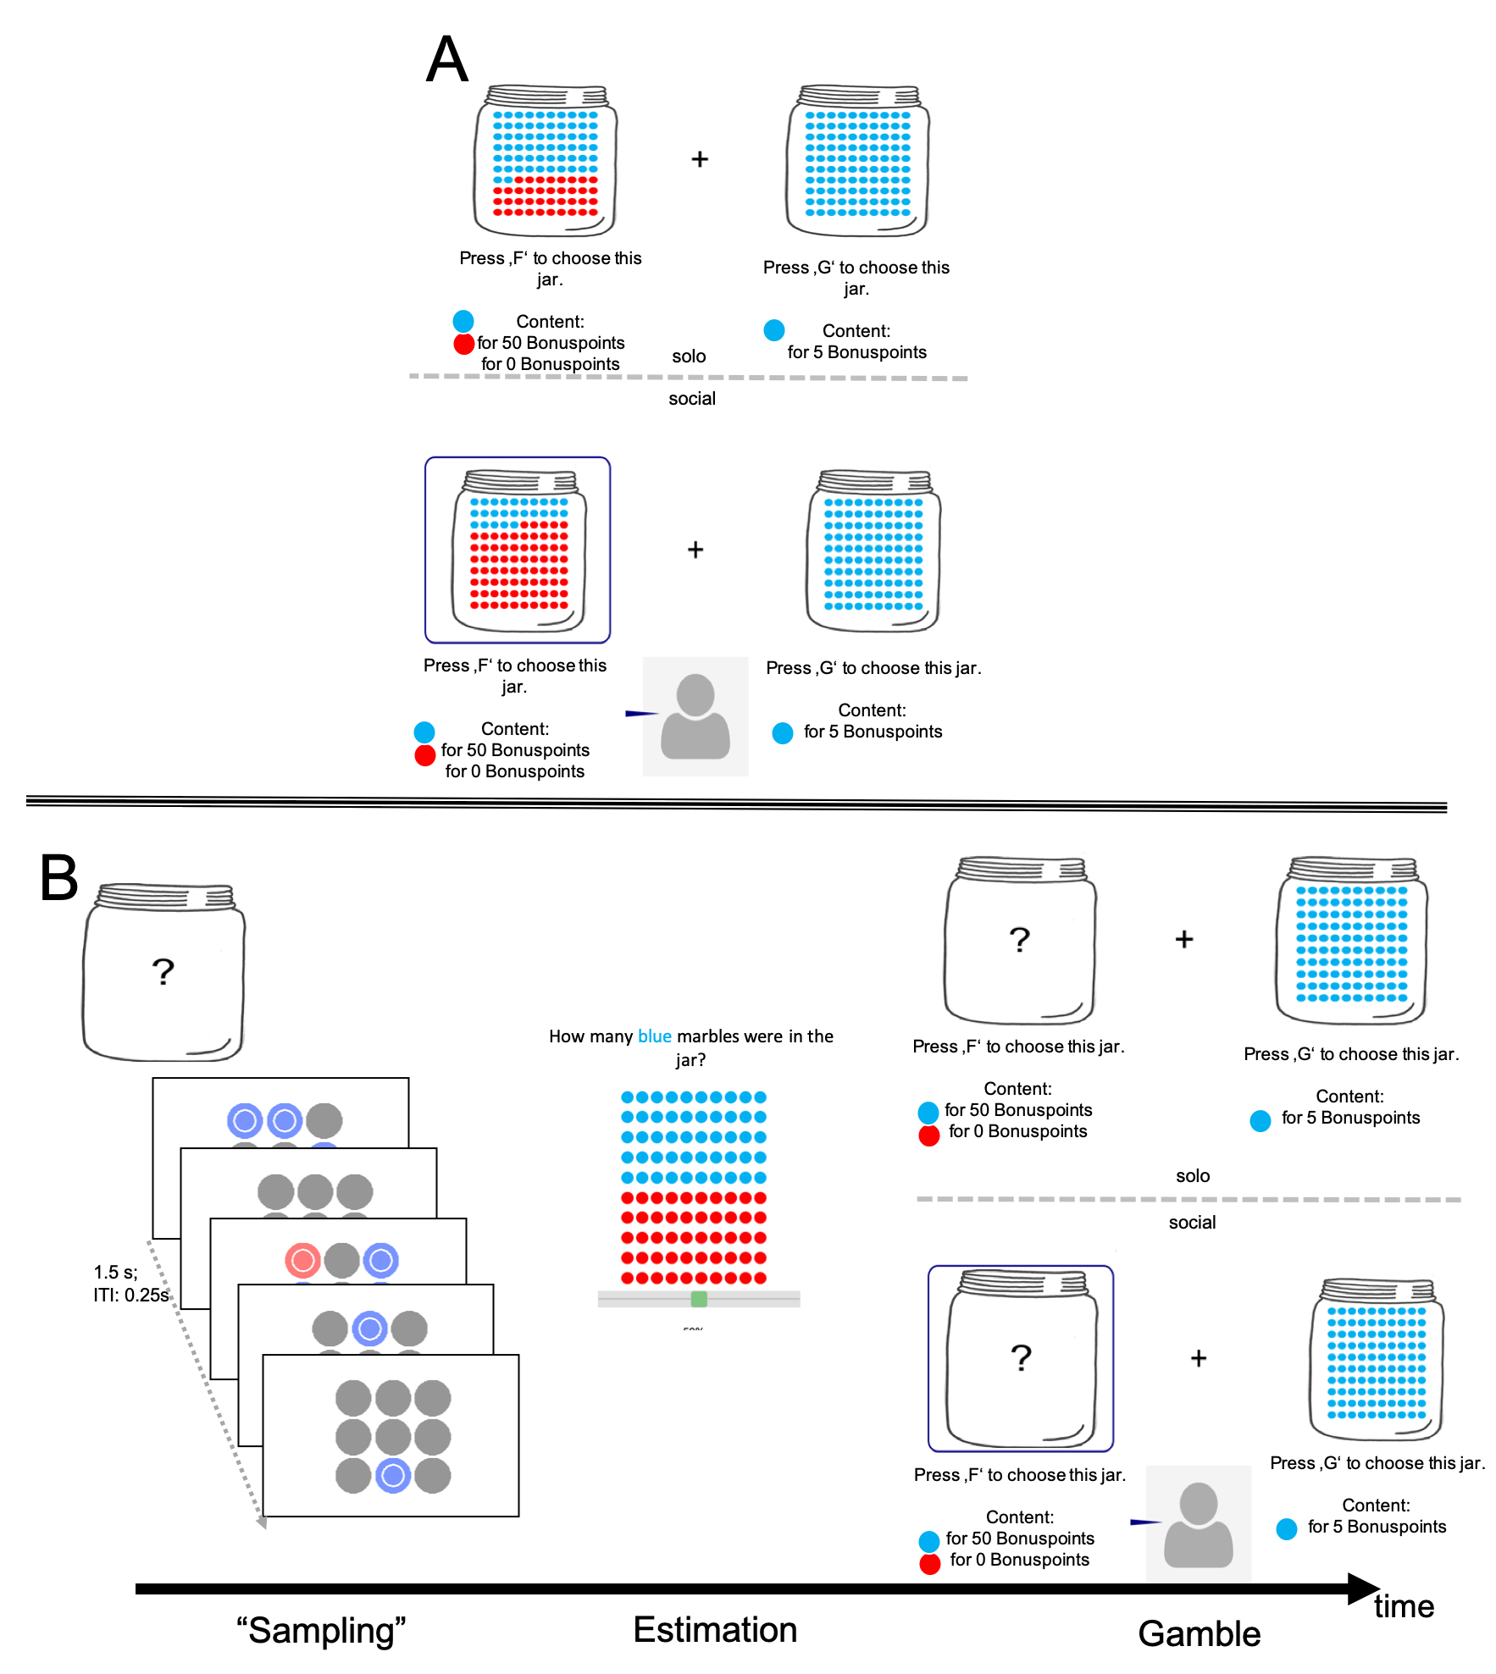Figure 1: The marble task, where subjects decide between a risky or a safe option. A) Subjects make decisions under risk. This means that outcome probabilities are described to the subjects. Subjects can either decide between a safe but small bonus or for a higher bonus that is only granted with the described probability. Decisions are either made with (bottom) or without (top) social information. B) Subjects make decisions under uncertainty. This means that they experience a sequence of possible outcomes which are sampled from the outcome distribution and are then asked to indicate their estimate of the underlying probabilities on a slider. Then they decide whether they want to gamble with the distribution they had just experienced or gain a small amount of bonus points with certainty. Subjects either are presented with social information (bottom) or not (top).

A main focus of this work was to quantify how susceptibility to social influence under uncertainty develops across adolescence. To this end we developed a computational model which formalizes the assumption that social influence depends on individually experienced uncertainty (Toelch & Dolan, 2015). The model rests on three building blocks.

First, there is risk attitude. We model risk attitude by borrowing concepts from the expected utility framework. According to expected utility, individual differences in reward sensitivity govern how likely individuals are to take risks. If individuals are highly sensitive to rewards, they will be more inclined to take a risk in order to obtain these rewards. Differences in reward sensitivity are usually modelled with a power function where exponents lower than one indicate risk aversion and values higher than one risk seeking policies:

By examining how the values for differ across age groups we thus quantify how reward sensitivity develops.

Second, there is inference and uncertainty. In the marble task, subjects are asked to decide between a risky option where blue marbles have a high value, but only will be drawn with some probability or a safe option where blue marbles have a low value but will be drawn for sure. For the risky option, subjects learn about the probability of obtaining a blue marble based on observing either a sequence of draws from the jar when making decisions under uncertainty, or the proportion of red and blue marbles directly, when making decisions under risk. We model individual beliefs about the outcome utilities by multiplying the utility with a Beta distribution. Under uncertainty, learning is modelled via Bayesian updating equations where observing a blue marble increments the alpha and observing a red marble the beta parameter of the Beta distribution. Under risk the mean of the beta is directly given by the probability. In both conditions, we fit a parameter allowing individual variation in uncertainty. In decisions under uncertainty, individual differences in representing uncertainty are modelled with the parameter , which can take different values for blue or red marbles. Under risk, individual uncertainties are estimated with the parameter .

We then combine these two components, reward sensitivity and uncertainty, by multiplying the beta distribution with the utility.

This way, we are able to quantify individual uncertainty about the utility yielded by the risky option (figure 2) and can remain agnostic about potential sources of this uncertainty, we are solely interested in the *effect of* these uncertainties on using social information and how this effect changes across development.

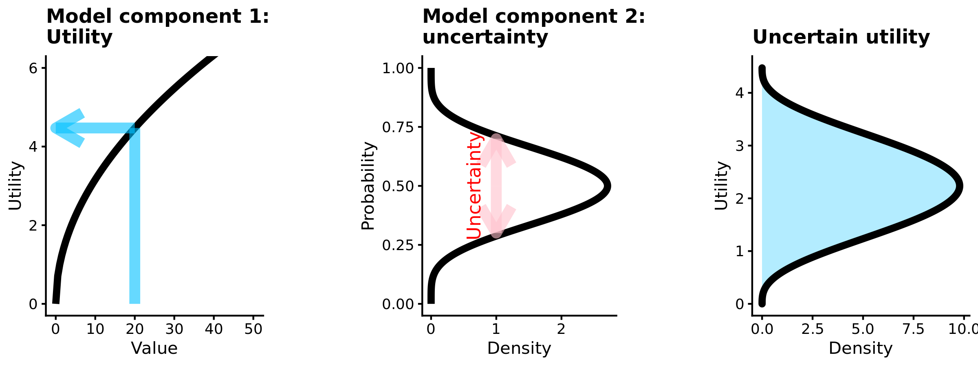Figure 2: Uncertain utility model for one option with a value of 20 which is granted with a probability about which the decision maker is uncertain. Component 1: Objective values (x axis) are transformed into a subjective utility (y-axis) using a power function, where the curvature of the utility function expresses reward sensitivity. Shown is the utility function of a risk averse individual who subjectively compresses rewards. Component 2: Beta distribution which expresses the probability that the probability that this outcome will be granted with some uncertainty. Convoluting the two components results in a distribution over Utilities that the risky option could have.

Third, there is social influence where we quantify the following scenario: If someone observes risky social information, this will make them believe that the risky option is more advantageous than previously thought based on individual information alone. If someone observes safe social information it will make them believe that the risky option is less advantageous than previously thought. We model social influence as Bayesian updating. From a Bayesian point of view, uncertainty is a mechanism of belief change. Therefore, individual uncertainties from the second part of the model will increase the propensity for social influence in the third part of the model. The posterior utility after observing social information is proportional to prior beliefs that have been formed based on individual information alone.

Differences in social information use are modelled with the parameter . In our formulation, this parameter can take different values depending on whether social information is presented under risk or uncertainty and whether it advocates safe or risky choices. EU corresponds to the result of Eq2. The probability to choose risk, , is then obtained by integrating over the posterior utility distribution, given social information, between the utility offered by the safe option and infinity:

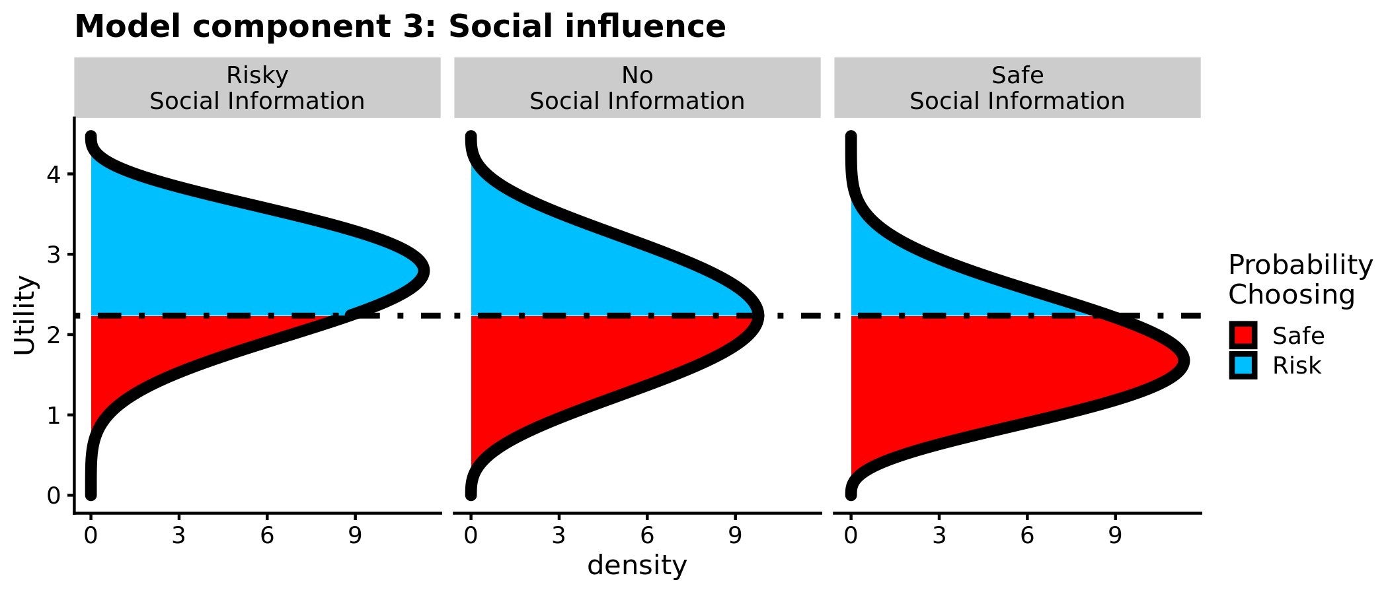

Figure 3: Social Utility Model. The probability to choose the safe option with a utility of 5 on a given trial is determined by the integral from 0 to the utility of the safe choice option (vertical black line). Social information skews the distribution which results either in a riskier (A) or safer (C) decision policy as compared to a choice problem which is subject the same underlying utilities and probabilities, but does not feature any social information (B).

Finally, a risky choice in a given trial is treated as a Bernoulli distributed random variable:

.

The elegance of this model is that it we integrate three mechanisms which are known to develop through adolescence, namely: reward sensitivity, processing of uncertainty and social influence into one single cognitive model.

Additionally, this modelling approach enables us to formalize alternative assumptions about the nature of social influence during adolescence. In accordance with the framework presented in Ciranka & van den Bos, (2019) we therefore implemented two alternative models. In the model presented above, we assume that individuals use social information differentially and rely on both, risky and safe advice in order to inform their decision. However, alternative views of social influence during adolescent exist. One of which is that a social context makes adolescents more sensitive towards rewards. We formalize this view by invoking a strictly positive, free parameter on the “reward sensitivity” part of each subjects’ utility function, that occurs when social information is present:

.

Increased distraction has also been discussed as a mechanism determining adolescent decision making under uncertainty. Therefore, we introduce another model which augments the probability to choose risk with a “trembling hand” error term that relates to the probability of guessing in a social context

.

After fitting all of these models to the same data, we can perform approximate a leave one out cross validation, to judge which model has the best predictive accuracy for our subjects’ behaviour. We judge the expected predictive accuracy of the models by consulting the expected log posterior predictive density (elpd), where the larger values speak for a more appropriate model. Note, that we deviate from our preregistration, where we registered a model comparison based on DIC. We chose to do so because elpd has been put forth as the more accurate metric. However, DIC yields similar results and can be found in the supplement.

While the models themselves constitute Bayesian models of cognition, we also formulated the models in a hierarchical Bayesian way (graphical model structure in the supplement). In the developmental context of this article this was especially advantageous because this procedure allowed us to estimate different hyper distributions for different age groups. Age groups were specified as: pre-adolescence (age: 10-12), early adolescence (age: 13-15), mid adolescence (age: 16-19), late adolescence, (age: 20 – 23) and post adolescence (age: > 23). Model fitting was done using stan (Carpenter et al., 2017), with 3 chains and 3000 iterations per chain, 500 of which we discarded as warmup. Convergence of the Markov Chains was inspected visually and by consulting (all=1). For inference on the relationship between age and the model parameters, we estimate Bayesian linear regression models, using normalized age and squared normalized age as predictors of the fitted model parameters. A precondition for inference based on fitted model parameters is that the parameters can reliably be identified by the fitting procedure. To establish this, we chose 20 evenly spaced values for each parameter within the parameter boundaries and then simulated responses under all possible combinations of these parameters. Then we fit the model again for each unique parameter combination, using a quasi-newton optimization algorithm and judged the correlations between simulated and recovered parameters.

In our preregistered “model free” analysis, we inspected whether the experimental manipulations had different effects on our subjects’ decisions, depending on their age. For this we constructed a Bayesian generalized linear model; predicting each decision with a logit link function, by coding a risky choice as “1” and a safe choice as “0”. We used the uncertainty conditions and the quality of social information as categorical predictors and the expected value of each decision as continuous predictor. We also included orthogonal linear and quadratic polynomials of our subjects age and their interactions with our experimental manipulations. By including regressors for working memory capacity as measured by the digit span task and fluid intelligence as measured by Raven matrices, we attempted to control for cognitive factors which might otherwise be a confound in developmental data. Finally, and erroneously not specified in the preregistration, we included random intercepts per subject. All statistical inference was performed using the brms package for R (Bürkner, 2017), using brms default priors.

***Results:***

In the present study we examined the developmental trajectories of social influence under different types of uncertainty by using a novel experimental paradigm and also by specifying a formal model of social influence. Before we turn to the modelling results, we examine the logistic regression and descriptive statistics. In general, the propensity to make a risky decision declined with age in all conditions (b_age= -50.24 -CI = [-82.93, -17.26]), whereas no quadratic agetrend was observed (b_age^2= -50.24 -CI = [-82.93, -17.26]), irrespective of whether social information was present or not (figure 4). All subjects reacted to social information as predicted. When social information was favouring risky decisions, subjects opted more for the risky option (*m* = 54.29%, *CI =* [53.19%, 55.38%]) than when making decisions alone (*m* = 46.89% *CI* = [46.00%, 47.78%]). When social information favoured safe decisions, subjects chose the risky option less often (*m* = 39.54%, *CI* = [38.02%, 41.07%]). Statistical analysis using a multilevel regression imply that more risk taking occurred when social information was risky (b_socialrisk = 0.26, *CI* = [0.16, 0.37]). However, we did not find a main effect of safe social information (b_socialsafe = 0.06 CI= [-0.08 – 0.20]).

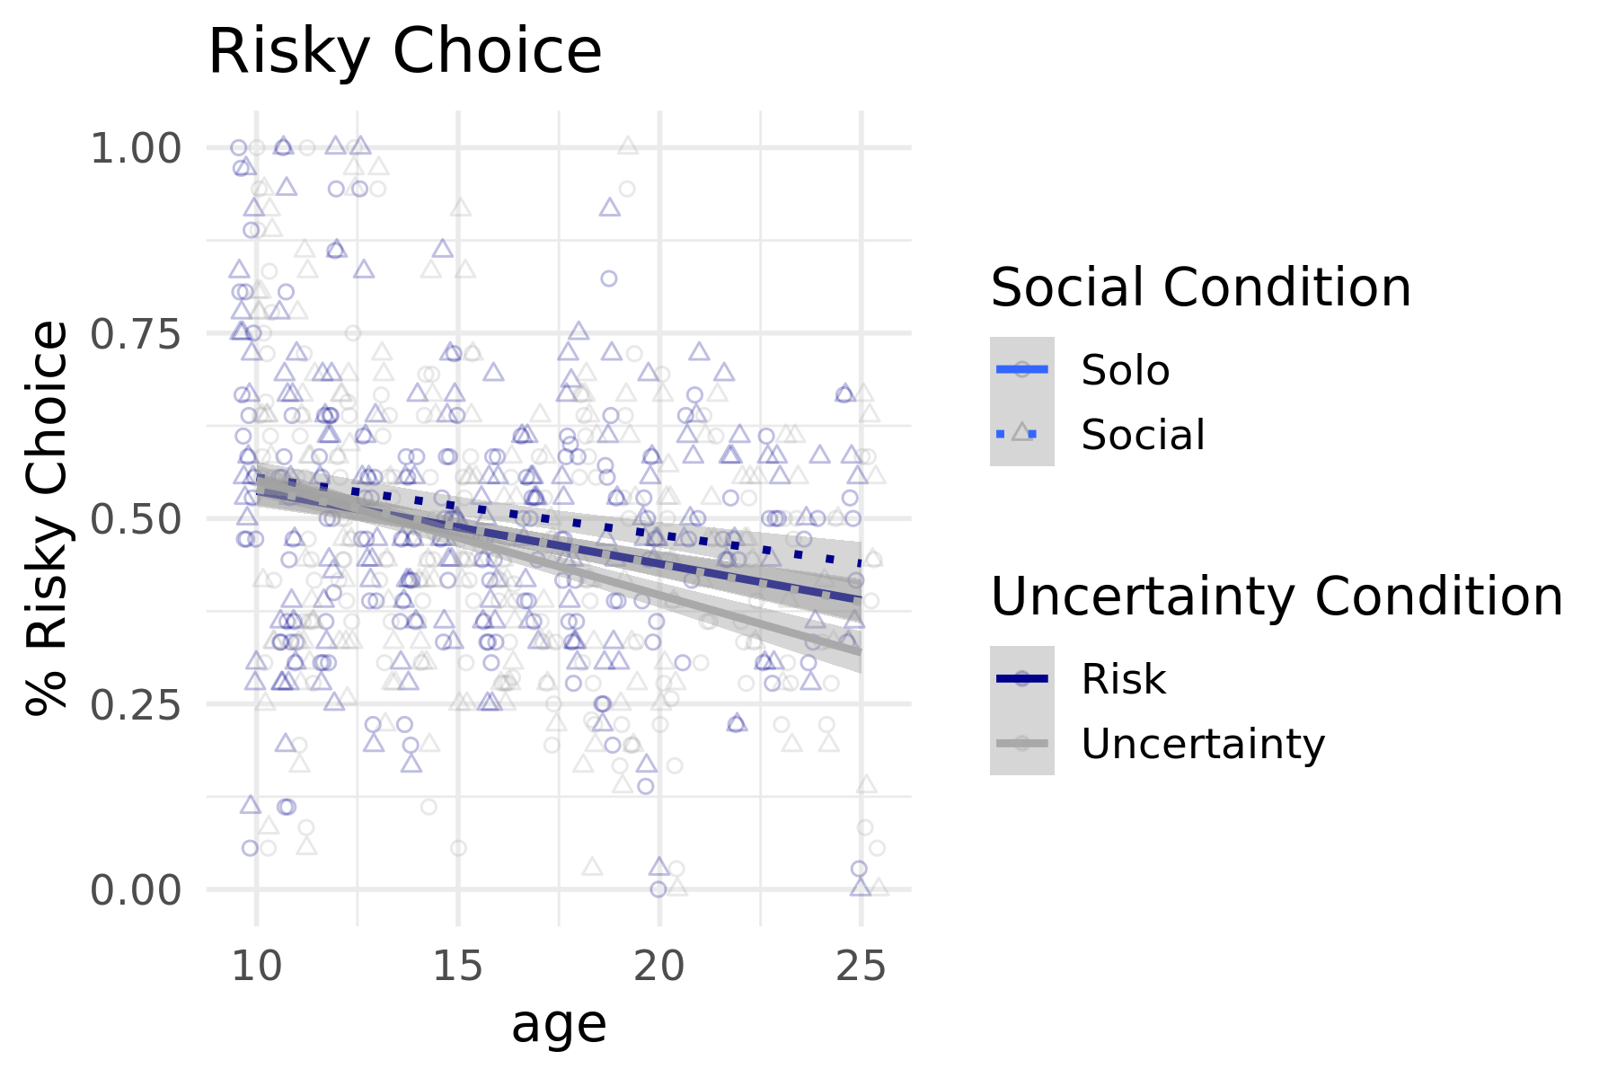

Figure 4: Risk taking, social information use and age. Grey are decisions under uncertainty, blue decisions under risk. Circles correspond to subject level means of risky choice when decisions were made without social information. An age trend for decisions without social information is plotted in the solid linear trendline. The triangles as well as the dotted trendlines correspond to decisions made in the presence of social information.

Now let us focus on our preregistered hypothesis. First, we were interested whether people used social information more, when there was more uncertainty in the task. We tested this by examining how social information interacted with uncertainty. When social information was risky, we did not find any credible interaction (b_risky:uncertain= -0.02, CI=[ -0.13, 0.17]). However, when social information was safe, people tended to use more social information under uncertainty than under risk (b_safe:uncertain= -0.30, CI=[ -0.51, -0.09]). This interaction is in contrast to the above reported main effect for social information use, in which only risky social information was predictive of the subjects’ choice.

The second preregistered hypothesis was that adolescents would make more risky decisions when there is more uncertainty. This relates to the positive interaction between quadratic age and the experimental uncertainty manipulations. This interaction was not credible (b_age^2:uncertain= 3.85, CI=[ -11.74, 18.38]). Interestingly and not preregistered by us, the same interaction was strongly negative and credible for the linear age term (b_age^2:uncertain= -28.72, CI=[ -43.74, 13.53]), suggesting that during development individuals increasingly differentiate between risk and uncertainty.

The third hypothesis stated that adolescents generally use more social information irrespective of uncertainty. This was tested with the interaction between quadratic age and social information use. This hypothesis was only true for safe social information (b_safe:age^2= - -31.15, CI=[ -53.76, -8.95]), but not for risky social information (b_risk: age^2= 3.07, CI=[-13.46, 19.41]).

The fourth preregistered hypothesis was the most specific of our hypotheses. We were interested in whether the interaction between uncertainty and information use is less strong during adolescence, as compared to members of other age groups. This corresponds to a negative three-way interaction between social information use, uncertainty and quadratic age. This interaction was not credible either for safe (b_safe:uncertain:age^2= -6.60, CI= [-13.75,26.29]), nor for risky social information (b_risky:uncertain:age^2= 6.14, CI= [ -17.85, 29.37]). The same interaction was also not credible using a linear age predictor for either safe (b_safe:uncertain:age= 30.23, CI= [-1.62,61.77]), or risky social information (b_safe:uncertain:age= 13.60, CI= [-8.84,37.67]).

**Model based Analysis**.

Here we report the parameter estimates obtained from fitting the above outlined model to our subjects’ decisions. First and foremost, we conform our last preregistered hypothesis, as we found that a model which integrates safe and risky social information describes our subjects’ behaviour better than models which assume that a social context makes our subjects more reward sensitive or makes them more distracted (elpd = 671). We emphasise that our proposed model captures the behaviour of subjects in all age groups well, which can be seen in figure 5.

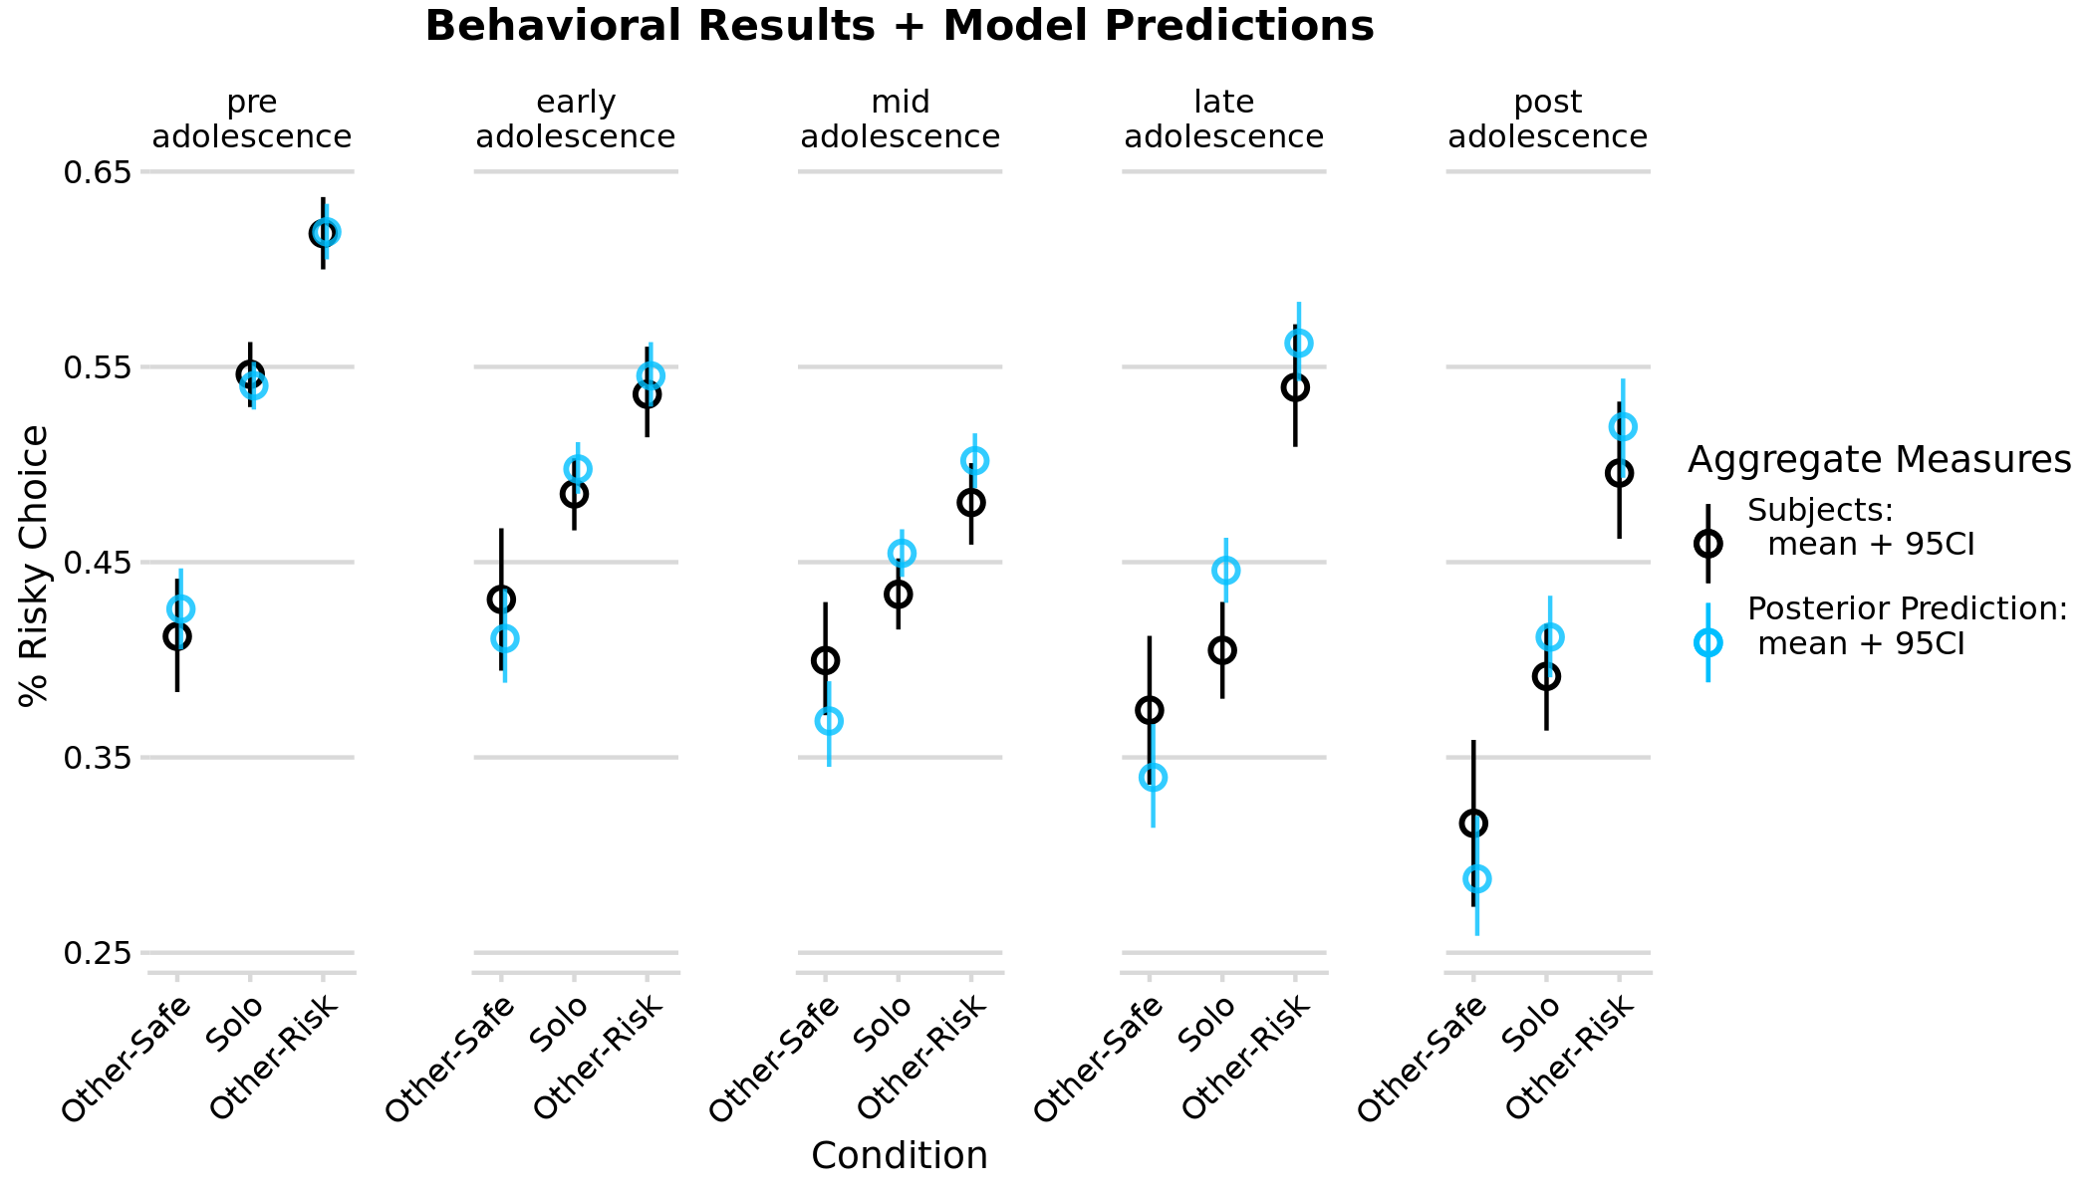

Figure 5: Percentage of risky choice by developmental stage and quality of social information. Black circles denote the subject mean with 95% CI. Mean and 95%CI form simulations under the full posterior are plotted in blue.

Our results show that people use social information more when they are more uncertain of how to decide. This is implied by the higher social influence parameter estimates, when there is uncertainty, as opposed to risk alone. This difference is in the range of a medium effect size, (posterior mean of d = 0.62), but seems to be driven mostly by safe social information. Formal modelling of our subjects’ decisions reveals linear developmental change in all parameters. Reward sensitivity decreased with age, towards a utility function which implies risk aversion (). At the same time, individuals’ representation of uncertainty became more accurate with age and was on average most optimal in the oldest individuals tested (). Social influence for safe and for risky social information decreased with age under risk and under uncertainty. When social information was risky, there was no considerable difference between the uncertainty and risk condition, however, when social information was safe, subjects integrated this information more into their decision, when they were more uncertain. Taken together we show behaviourally and computationally that subjects who were subjectively more uncertain, used social information more, despite the fact that every subject observed the same amount of information.

This underweighting leads to higher uncertainty and this uncertainty explains why subjects overestimate low and underestimate high probabilities (=0.38, CI=[0.36,0.40]). Subjective uncertainty results in the observed regression to the mean of our subjects probability estimates (figure 4b).

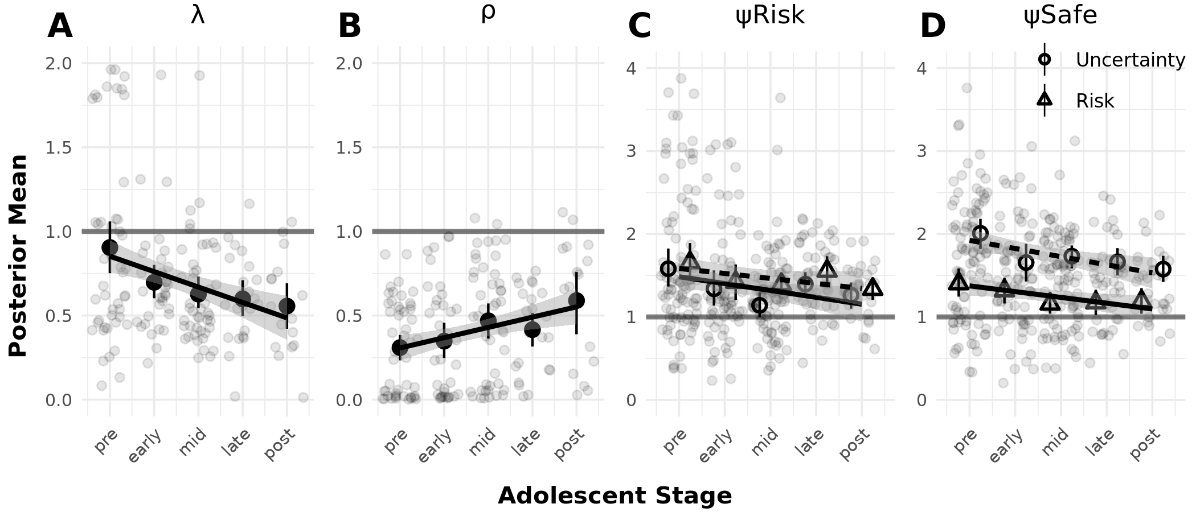

Figure 6: Age trends in the parameter estimates of the social influence model. A) Shows the age trajectories of a parameter relating to risk attitudes, showing a steady increase in risk aversion through development. It should be noted that even the youngest age-group is risk averse on average as shown by a mean parameter estimate smaller than 1. B) Across development, subjects become more accurate in integrating new information into their beliefs which is shown by a linear age trend in this parameter. C) When subjects observe risky social information, they use social information in a similar fashion under risk and uncertainty. Youngest subjects use social information most and the use of social information linearly declines during development. The same age trend is true for safe social information; however, we show that under uncertainty, all individuals rely more on safe social information than under risk.

Notably, subjects put a stronger weight on social information as compared to individual information. This is implied by the posterior mean estimates of , which constitute the weight of social information on our subjects’ decisions. was almost exclusively greater than 1 (*m* = 2.40, *sd* = 1.51), irrespective of varying rule and outcome uncertainty. This means that one piece of advice had a higher influence on our subject’s choice than one piece of individual evidence. In sum, we show that uncertainty leads to less risky decisions and more social influence, at least when social information promotes safe behaviours. Individuals become more risk averse and better at representing uncertainty as they age. They also use social information less across adolescence under risk and under uncertainty.

***Discussion***

In this study we investigated how social information impacts risk taking under different types of uncertainty across adolescence. To this end, we introduced a novel experimental paradigm to study learning and decision making under risk and uncertainty, which aimed at decoupling learning and decision processes. In order to get better insights in the development of social influence mechanisms under uncertainty, we formulated a Bayesian model of social influence and compared its appropriateness to frequently employed alternative explanations about the nature of social influence during adolescence. Here, we highlight and discuss our main findings.

First, we provide converging evidence from formal modelling and Bayesian regression analysis that risky decisions become less prevalent with age, irrespective of uncertainty. This is in line with the results of a recent meta-analysis on the development of risk-taking (Defoe et al., 2014) and extends them from the world of risk, to the world of uncertainty. We therefore reject the preregistered hypothesis that adolescents in particular would be more prone for risk-taking under uncertainty than under risk. Much rather it seems like across development, individuals learn to better differentiate between risk and uncertainty (cf figure) and oldest individuals are most risk averse under uncertainty. This finding is in contrast to previous studies where adolescents where found to be more tolerant towards uncertainty than children or adults (van den Bos & Hertwig, 2017). However, adolescence is often not only understood as a period with exceptional tolerance towards uncertainty (Rosenbaum et al., 2018; Tymula et al., 2012), but also as a period of heightened active exploration (Gopnik et al., 2017; Palminteri et al., 2016a; Rodriguez Buritica, Heekeren, & van den Bos, 2019). A key difference between our study and previous ones is that we did not ask individuals to explore possible outcomes, while research on decision making under uncertainty usually involves this explorative component (Daw, O’Doherty, Dayan, Seymour, & Dolan, 2006; Hertwig & Erev, 2009; Nassar et al., 2016; Nussenbaum & Hartley, 2019; van den Bos & Hertwig, 2017). As we do not find evidence for nonlinear attitudes towards uncertainty *per se* future research should investigate the role of agency in exploration during adolescence. This will be particularly interesting to investigate from a social standpoint because the developmental milestone of adolescence is to eventually become an independent agent in a complex, social world (Blakemore, 2008).

Second, focusing on uncertainty we show that older subjects were better at integrating new information into their beliefs based on individual information. We show that most individuals put less weight on new pieces of information than would be optimal but oldest individuals are closest to an ideal Bayesian observer. Taken together, we show that under uncertainty individuals adapt their beliefs better in the light of new information and increasingly differentiate between uncertainty and risk. This conforms a proposal based on a review of recent developmental studies which use reinforcement learning, wherein it was speculated that across development, individuals get gradually better at integrating new information adequately into their prior beliefs (Nussenbaum & Hartley, 2019). However, previous studies have been subject to confounds such as developmental differences in exploration (van den Bos & Hertwig, 2017), or learning from errors (Davidow et al., 2016; Palminteri, Kilford, Coricelli, & Blakemore, 2016). With our novel experimental paradigm, we now provide firmer evidence in favor of this interpretation.

Third, confirming our next preregistered hypothesis, model comparison based on approximate leave one out cross validation suggests that social information use is best described with instrumental Bayesian inference as opposed to making individuals more distracted or sensitive to rewards in general. These results align with previous research (Ciranka & van den Bos, 2019) add further evidence that across adolescence, individuals pay close attention to the content of social information. However, it is still clear that social signals can lead adolescents into a vicious circle to take severe risks. Future work should identify the boundary conditions of adaptive social information use. For instance, in emotionally “hot” situations the situational arousal could still lead to increased distraction or reward sensitivity (Rosenbaum et al., 2018).

Fourth, we show that youngest individuals use social information most and across age, social information use steadily declines. On top of that linear trend, we find that adolescents use social information more than other age groups when it promotes safe decisions, but not when it promotes risky decisions. This result is partly in line with our preregistration because we did not expect differences between safe and risky information use. However, in the meantime, similar differences have been reported (Blankenstein et al., 2016; Braams et al., 2019; Ciranka & van den Bos, 2019). Using computational modelling it becomes evident that all individuals use safe social information more, when they are more uncertain of how to decide. These results are in contrast to reports, where adolescents become more liberal towards risk-taking after observing a risk-seeking peer (Knoll, Magis-Weinberg, Speekenbrink, & Blakemore, 2015; Reiter et al., 2019). This divergence might be explained by the nature of the social signals presented to subjects of different studies. When individuals merely observe the behavior of others social influence operates indirectly via descriptive social norms (Cialdini & Goldstein, 2004). Whereas when social information is given in the form of advice, like in our study, social influence occurs more directly. These diverging results therefore fall into the divergence between informational and normative social influence (Deutsch & Gerard, 1955), both of which are known to be powerful modulators of behavior. In order to better comprehend adolescent social information use and how it aligns with their prior beliefs, contrasting the impact of normative and informational social influence across development will be most insightful.

Finally, we cannot confirm our preregistered hypotheses that adolescents’ tolerance for uncertainty leads to nonlinear developmental trajectories of social information use. However, in the real world, it is clear that adolescent propensity to take risks is strongest when they are with their peers. The question arises which beliefs and which uncertainties elicit adolescent risk taking outside of the laboratory. Our study provides evidence that younger individuals often initially only have a vague idea of the possible consequences of their actions and the likelihoods of those consequences and calibrate their social information use to this circumstance. However, our results are not sufficient to explain that adolescents take more risks than children in the real world. A possible starting point to get a better grasp at adolescent social susceptibility is to establish and vary social norms experimentally to and to investigate how individual uncertainties about these norms impact social influence through development.

References

Albert, D., & Steinberg, L. (2011). Judgment and decision making in adolescence. *Journal of Research on Adolescence*, *21*(1), 211–224. https://doi.org/10.1111/j.1532-7795.2010.00724.x

Bahrami, B., Olsen, K., Latham, P. E., Roepstorff, A., Rees, G., & Frith, C. D. (2010). Optimally interacting minds. *Science (New York, N.Y.)*, *329*(5995), 1081–1085. https://doi.org/10.1126/science.1185718

Barch, D. M., Albaugh, M. D., Avenevoli, S., Chang, L., Clark, D. B., Glantz, M. D., … Sher, K. J. (2017). Demographic, physical and mental health assessments in the adolescent brain and cognitive development study: Rationale and description. *Developmental Cognitive Neuroscience*, *32*(November 2017), 55–66. https://doi.org/10.1016/j.dcn.2017.10.010

Blakemore, S.-J., & Mills, K. L. (2014). Is Adolescence a Sensitive Period for Sociocultural Processing? *Annual Review of Psychology*, *65*(1), 187–207. https://doi.org/10.1146/annurev-psych-010213-115202

Blakemore, S. J. (2008). The social brain in adolescence. *Nature Reviews Neuroscience*, *9*(4), 267–277. https://doi.org/10.1038/nrn2353

Blakemore, S. J., & Robbins, T. W. (2012). Decision-making in the adolescent brain. *Nature Neuroscience*, *15*(9), 1184–1191. https://doi.org/10.1038/nn.3177

Braams, B. R., Davidow, J. Y., & Somerville, L. H. (2019). Developmental patterns of change in the influence of safe and risky peer choices on risky decision-making. *Developmental Science*, *22*(1), e12717. https://doi.org/10.1111/desc.12717

Browning, M., Behrens, T. E., Jocham, G., O’Reilly, J. X., & Bishop, S. J. (2015). Anxious individuals have difficulty learning the causal statistics of aversive environments. *Nature Neuroscience*, *18*(4), 590–596. https://doi.org/10.1038/nn.3961

Bürkner, P.-C. (2017). brms: An R Package for Bayesian Multilevel Models Using Stan. *Journal of Statistical Software*, *80*(1), 1–28. https://doi.org/10.18637/jss.v080.i01

Carpenter, B., Gelman, A., Hoffman, M. D., Lee, D., Goodrich, B., Betancourt, M., … Riddell, A. (2017). Stan : A Probabilistic Programming Language. *Journal of Statistical Software*, *76*(1), 1–32. https://doi.org/10.18637/jss.v076.i01

Chung, D., Christopoulos, G. I., King-Casas, B., Ball, S. B., & Chiu, P. H. (2015). Social signals of safety and risk confer utility and have asymmetric effects on observers’ choices. *Nature Neuroscience*, *18*(6), 912–916. https://doi.org/10.1038/nn.4022

Cialdini, R. B., & Goldstein, N. J. (2004). Social Influence: Compliance and Conformity. *Annual Review of Psychology*, *55*(1), 591–621. https://doi.org/10.1146/annurev.psych.55.090902.142015

Ciranka, S., & van den Bos, W. (2019). Social influence in adolescent decision-making: A formal framework. *Frontiers in Psychology*, *10*(AUG). https://doi.org/10.3389/fpsyg.2019.01915

Ciranka, Simon, & Bos, W. van den. (2020). A Bayesian Model of Social Influence under Risk and Uncertainty. *Proceedings of the 42ndth Annual Conference of the Cognitive Science Society*. https://doi.org/10.31234/OSF.IO/MUJEK

Ciranka, Simon, & van den Bos, W. (2019). Social Influence in Adolescent Decision-Making: A Formal Framework. *Frontiers in Psychology*, *10*, 1915. https://doi.org/10.3389/fpsyg.2019.01915

Crone, E. A., & Dahl, R. E. (2012). Understanding adolescence as a period of social-affective engagement and goal flexibility. *Nature Reviews Neuroscience*. https://doi.org/10.1038/nrn3313

Davidow, J. Y., Foerde, K., Galván, A., & Shohamy, D. (2016). An Upside to Reward Sensitivity: The Hippocampus Supports Enhanced Reinforcement Learning in Adolescence. *Neuron*. https://doi.org/10.1016/j.neuron.2016.08.031

Daw, N. D., O’Doherty, J. P., Dayan, P., Seymour, B., & Dolan, R. J. (2006). Cortical substrates for exploratory decisions in humans. *Nature*, *441*(7095), 876–879. https://doi.org/10.1038/nature04766

de Leeuw, J. R. (2015). jsPsych: A JavaScript library for creating behavioral experiments in a Web browser. *Behavior Research Methods*, *47*(1), 1–12. https://doi.org/10.3758/s13428-014-0458-y

Defoe, I. N., Dubas, J. S., Figner, B., & Aken, M. a G. Van. (2014). A Meta-Analysis on Age Differences in Risky Decision Making : Adolescents Versus Children and Adults A Meta-Analysis on Age Differences in Risky Decision Making: Adolescents Versus Children and Adults. *Psychological Bulleti*, *141*(July), 48–84. https://doi.org/10.1037/a0038088

Defoe, I. N., Dubas, J. S., Figner, B., & van Aken, M. A. G. (2015). A meta-analysis on age differences in risky decision making: Adolescents versus children and adults. *Psychological Bulletin*, *141*(1), 48–84. https://doi.org/10.1037/a0038088

Defoe, I. N., Semon Dubas, J., & Romer, D. (2019). Heightened Adolescent Risk-Taking? Insights From Lab Studies on Age Differences in Decision-Making. *Policy Insights from the Behavioral and Brain Sciences*, *6*(1), 56–63. https://doi.org/10.1177/2372732218801037

Deutsch, M., & Gerard, H. B. (1955). A study of normative and informational social influences upon individual judgment. *The Journal of Abnormal and Social Psychology*, *51*(3), 629–636. https://doi.org/10.1037/h0046408

FeldmanHall, O., & Shenhav, A. (2019). Resolving uncertainty in a social world. *Nature Human Behaviour*, *3*(5), 426–435. https://doi.org/10.1038/s41562-019-0590-x

Gardner, M., & Steinberg, L. (2005). Peer Influence on Risk Taking, Risk Preference, and Risky Decision Making in Adolescence and Adulthood: An Experimental Study. *Developmental Psychology*, *41*(4), 625–635. https://doi.org/10.1037/0012-1649.41.4.625

Gopnik, A., Griffiths, T. L., & Lucas, C. G. (2015). When Younger Learners Can Be Better (or at Least More Open-Minded) Than Older Ones. *Current Directions in Psychological Science*, *24*(2), 87–92. https://doi.org/10.1177/0963721414556653

Gopnik, A., O’Grady, S., Lucas, C. G., Griffiths, T. L., Wente, A., Bridgers, S., … Dahl, R. E. (2017). Changes in cognitive flexibility and hypothesis search across human life history from childhood to adolescence to adulthood. *Proceedings of the National Academy of Sciences*, *114*(30), 7892–7899. https://doi.org/10.1073/pnas.1700811114

Haddad, A. D. M., Harrison, F., Norman, T., & Lau, J. Y. F. (2014). Adolescent and adult risk-taking in virtual social contexts. *Frontiers in Psychology*, *5*(DEC), 1–7. https://doi.org/10.3389/fpsyg.2014.01476

Hauser, T. U., Will, G.-J., Dubois, M., & Dolan, R. J. (2018). Developmental Computational Psychiatry. https://doi.org/10.31234/OSF.IO/85PRQ

Hertwig, R., & Erev, I. (2009). The description-experience gap in risky choice. *Trends in Cognitive Sciences*, *13*(12), 517–523–600. https://doi.org/https://doi.org/10.1016/j.tics.2009.09.004

Knoll, L. J., Magis-Weinberg, L., Speekenbrink, M., & Blakemore, S.-J. (2015). Social Influence on Risk Perception During Adolescence. *Psychological Science*. https://doi.org/10.1177/0956797615569578

Lejuez, C. W., Aklin, W. M., Jones, H. A., Richards, J. B., Strong, D. R., Kahler, W. C., & Read, J. P. (2003). The Balloon Analogue Risk Task (BART) Differentiates Smokers and Nonsmokers. *Experimental and Clinical Psychopharmacology*, *11*(1). https://doi.org/10.1037//1064-1297.11.1.26

Molleman, L., Kurvers, R. H. J. M., & van den Bos, W. (2019). Unleashing the BEAST: a brief measure of human social information use. *Evolution and Human Behavior*, *40*(5), 492–499. https://doi.org/10.1016/J.EVOLHUMBEHAV.2019.06.005

Moussaïd, M., Herzog, S. M., Kämmer, J. E., & Hertwig, R. (2017). Reach and speed of judgment propagation in the laboratory. *Proceedings of the National Academy of Sciences*, *114*(16), 4117–4122. https://doi.org/10.1073/pnas.1611998114

Nassar, M. R., Bruckner, R., Gold, J. I., Li, S., Heekeren, H. R., & Eppinger, B. (2016). Age differences in learning emerge from an insufficient representation of uncertainty in older adults. *Nature Communications*, *7*(May 2015), 1–13. https://doi.org/10.1038/ncomms11609

Nussenbaum, K., & Hartley, C. A. (2019). Reinforcement learning across development: What insights can we draw from a decade of research? *Developmental Cognitive Neuroscience*, *40*, 100733. https://doi.org/10.1016/J.DCN.2019.100733

Palminteri, S., Kilford, E. J., Coricelli, G., & Blakemore, S.-J. (2016a). The Computational Development of Reinforcement Learning during Adolescence. *PLOS Computational Biology*, *12*(6), e1004953. https://doi.org/10.1371/journal.pcbi.1004953

Palminteri, S., Kilford, E. J., Coricelli, G., & Blakemore, S.-J. (2016b). The Computational Development of Reinforcement Learning during Adolescence. *PLOS Computational Biology*, *12*(6), e1004953. https://doi.org/10.1371/journal.pcbi.1004953

Pfeifer, J. H., Allen, N. B., Byrne, M. L., & Mills, K. L. (2018). Modeling Developmental Change: Contemporary Approaches to Key Methodological Challenges in Developmental Neuroimaging. *Developmental Cognitive Neuroscience*, *33*, 1–4. https://doi.org/10.1016/J.DCN.2018.10.001

Powers, A. R., Mathys, C., & Corlett, P. R. (2017). Pavlovian conditioning–induced hallucinations result from overweighting of perceptual priors. *Science*, *357*(6351), 596–600. https://doi.org/10.1126/science.aan3458

Reiter, A. M. F., Suzuki, S., O’Doherty, J. P., Li, S.-C., & Eppinger, B. (2019). Risk contagion by peers affects learning and decision-making in adolescents. *Journal of Experimental Psychology: General*. https://doi.org/10.1037/xge0000512

Rodriguez Buritica, J. M., Heekeren, H. R., & van den Bos, W. (2019). The computational basis of following advice in adolescents. *Journal of Experimental Child Psychology*, *180*, 39–54. https://doi.org/10.1016/J.JECP.2018.11.019

Rosenbaum, G. M., & Hartley, C. A. (2019). Developmental perspectives on risky and impulsive choice. *Philosophical Transactions of the Royal Society B: Biological Sciences*, *374*(1766), 20180133. https://doi.org/10.1098/rstb.2018.0133

Rosenbaum, G. M., Venkatraman, V., Steinberg, L., & Chein, J. M. (2018). The influences of described and experienced information on adolescent risky decision making. *Developmental Review*, *47*, 23–43. https://doi.org/10.1016/j.dr.2017.09.003

Schonberg, T., Fox, C. R., & Poldrack, R. A. (2011). Mind the gap: bridging economic and naturalistic risk-taking with cognitive neuroscience. *Trends in Cognitive Sciences*, *15*(1), 11–19. https://doi.org/10.1016/j.tics.2010.10.002

Schulz, E., Wu, C. M., Ruggeri, A., & Meder, B. (2019). Searching for Rewards Like a Child Means Less Generalization and More Directed Exploration. *Psychological Science*, *30*(11), 1561–1572. https://doi.org/10.1177/0956797619863663

Smith, A. R., Chein, J., & Steinberg, L. (2014). Peers increase adolescent risk taking even when the probabilities of negative outcomes are known. *Developmental Psychology*, *50*(5), 1564–1568. https://doi.org/10.1037/a0035696

Telzer, E. H., van Hoorn, J., Rogers, C. R., & Do, K. T. (2018). Social Influence on Positive Youth Development: A Developmental Neuroscience Perspective. *Advances in Child Development and Behavior*, *54*, 215–258. https://doi.org/10.1016/BS.ACDB.2017.10.003

Toelch, U., & Dolan, R. J. (2015). Informational and Normative Influences in Conformity from a Neurocomputational Perspective. *Trends in Cognitive Sciences*, *19*(10), 579–589. https://doi.org/10.1016/J.TICS.2015.07.007

Tymula, A., Rosenberg Belmaker, L. A., Roy, A. K., Ruderman, L., Manson, K., Glimcher, P. W., & Levy, I. (2012a). Adolescents’ risk-taking behavior is driven by tolerance to ambiguity. *Proceedings of the National Academy of Sciences*, *109*(42), 17135–17140. https://doi.org/10.1073/pnas.1207144109

Tymula, A., Rosenberg Belmaker, L. A., Roy, A. K., Ruderman, L., Manson, K., Glimcher, P. W., & Levy, I. (2012b). Adolescents’ risk-taking behavior is driven by tolerance to ambiguity. *Proceedings of the National Academy of Sciences*, *109*(42), 17135–17140. https://doi.org/10.1073/pnas.1207144109

van den Bos, W., Bruckner, R., Nassar, M. R., Mata, R., & Eppinger, B. (2017). Computational neuroscience across the lifespan: Promises and pitfalls. *Developmental Cognitive Neuroscience*. https://doi.org/10.1016/J.DCN.2017.09.008

van den Bos, W., Cohen, M. X., Kahnt, T., & Crone, E. A. (2012). Striatum–Medial Prefrontal Cortex Connectivity Predicts Developmental Changes in Reinforcement Learning. *Cerebral Cortex*, *22*(6), 1247–1255. https://doi.org/10.1093/cercor/bhr198

van den Bos, W., & Hertwig, R. (2017). Adolescents display distinctive tolerance to ambiguity and to uncertainty during risky decision making. *Scientific Reports*, *7*(December 2016), 40962. https://doi.org/10.1038/srep40962